**HAZARD COMMUNICATION LABEL AND**

**SAFETY DATA SHEET TRAINING**

Per DOC 890.070 Chemical Control and HAZCOM, all workers who may come in contact with hazardous chemicals under normal operating/working conditions must receive training in assessing potential chemical hazards. Hazard Communication (HAZCOM) training will be provided at the Reception Diagnostic Centers and reviewed by all current incarcerated workers.

The Department of Labor and Industries has adopted rules, as required by the federal Occupational Safety and Health Administration (OSHA), to incorporate the Globally Harmonized System of Classification and Labeling of Chemicals. This handout outlines the OSHA Hazard Communication Standard (HCS), including chemical label and Safety Data Sheet (SDS) guidelines.

**Labeling Guidelines**

1. **Product identifier:**  The product/chemical label must include the same name of the product/ chemical or the manufacturer identification number that is used on the SDS.
2. **Pictogram(s):** Pictures that visually identify the hazard associated with the chemical. Below is a list of recognized pictograms and the hazards they depict.
3. **Signal word:** “Warning” or “Danger” will be used to emphasize hazards and indicate the relative level of severity of the hazard. Some lower level hazard categories do not use signal words.
4. **Hazard statement(s):** Standard phrases that describe the nature of the hazard.
5. **Precautionary statement(s):** Statement(s) indicating the type of protective equipment that should be used when working with the chemical or advising of storage requirements.
6. **Name, address, and telephone number:** Refer to the SDS.

**Sample Label**

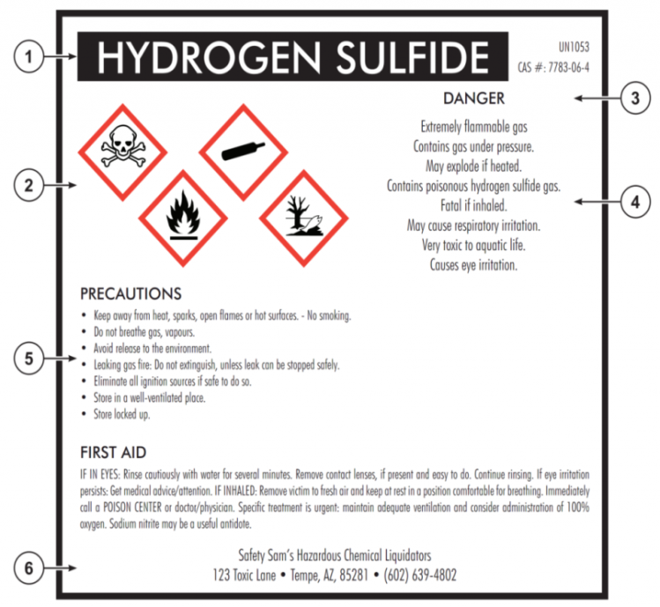

**HCS Pictograms and Hazards:**

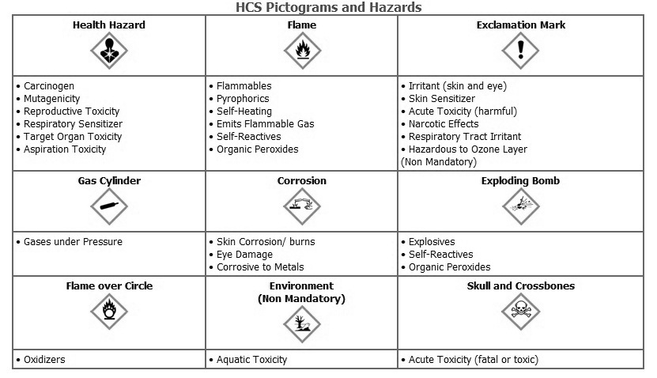

**Each SDS will have the following 16 sections, in order:**

Section 1 - Identification

Section 2 - Hazard(s) identification

Section 3 - Composition/information on ingredients

Section 4 - First aid measures

Section 5 - Firefighting measures

Section 6 - Accidental release measures

Section 7 - Handling and storage

Section 8 - Exposure controls/personal protection

Section 9 - Physical and chemical properties

Section 10 - Stability and reactivity

Section 11 - Toxicological information

Section 12 - Ecological information

Section 13 - Disposal considerations

Section 14 - Transport information

Section 15 - Regulatory information

Section 16 - Other information, including date of preparation/last revision

**I have been briefed on, read, and understand the chemical label and SDS guidelines.**

Name and DOC number Signature Date

**The contents of this document may be eligible for public disclosure. Social Security Numbers are considered confidential information and will be redacted in the event of such a request. This form is governed by Executive Order 16-01, RCW 42.56, and RCW 40.14.**

Distribution: **ORIGINAL** - Supervisor