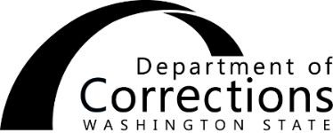
REQUEST FOR INFORMATION
REGARDING TRIBAL DEPOSITS
Name: DOC number:

The individual above is currently incarcerated in a correctional institution in the State of Washington. Monetary funds received are subject to deductions per RCW 72.09.480. Depending on the source, funds may be exempt from deductions. Please provide the following information to determine the source of funds:
Name of tribe:
Name of tribal agency, if applicable:
Source of funds (check all that apply):
1. Gaming revenue or enterprise businesses (e.g., casino, gas station, store, bowling alley)
2. Distributed according to the Alaska Native Claims Settlement Act per 43 U.S.C. § 1606 (i.e., Settlement Common Stock of a Regional Corporation)
3. Distributed according to the Indian Tribal Judgment Funds Use or Distribution Act per 43 U.S.C. § 1401 and 25 U.S.C.§ 117a-b (i.e., amounts which the Secretary of the Interior held in trust, satisfaction of judgments of Indian Claims Commission or United States Court of Federal Claims in favor of any Indian Tribe or payments regarding tribal restricted lands)
4. General Welfare Benefits 26 U.S.C. § 139E
Funding source if claiming exemption:
5. Distributed per court order
Explain, including court name and cause number:
6. Distributed per other federal law
Explain, including law citation and description:
Does the check/money order contain funds from multiple sources? Yes No
If yes, provide amount per source: $ from source number
$ from source number

Return the completed form and check/money order to Headquarters Business Services Trust Accounting Unit, including check/money order number and payment amount, or Department of Corrections at:
, WA.
Address City Zip code

Name Date

Title Phone number

The contents of this document may be eligible for public disclosure. Social Security Numbers are considered confidential information and will be redacted in the event of such a request. This form is governed by Executive Order 16-01, RCW 42.56, and RCW 40.14.

Distribution: ORIGINAL - Headquarters Business Office

