~~~~

**CARE AND USE OF RADIO FREQUENCY EQUIPMENT**

The HomeGuard 20/20 base station should be located in in a central location of the residence or a room you spend most of your time. It should be positioned at least 3 feet above the floor and not next to metal items, shelves or mirrors. It should also be out of direct sunlight and heavy traffic areas. Do not place the HomeGuard 20/20 on or near a computer, television, or stereo.

**Installation/Use of equipment**

Plug the power cord from the back of the base station into the wall socket.

**NOTE:** *Do not plug the base station into an outlet that is controlled by a light switch. Accidentally turning off the switch and base station can cause false power fail alerts.*

Verify the Power Cable Connected icon is green and the Connected to Network icon is green or yellow. If the Connected to Network icon is red, move the base station and power supply to another location and check the icons again.

Once both icons are not red, tap COMPLETE INSTALL. Leave the base station at that location and do not move it until your case manager instructs you to do so.

Always leave your bracelet around your ankle as installed by your case manager. Properly installed, the bracelet may be rotated from one area of your ankle to another. Periodically move the bracelet around your ankle to avoid leaving the bracelet in one place for an extended time period.

Regularly clean your ankle and the bracelet with mild soap and water. If you experience discomfort or a serious skin irritation at any time, immediately notify your case manager. Footwear should not interfere with the bracelet and must allow bracelet rotation around the ankle. If you are required to wear boots, they should be loosely tied to avoid pressing the bracelet against your leg.

The unit will call the monitoring center to report when you are out of range. When you return, the unit will pick up the transmitter and call the monitoring center to report you have returned in range.

Always go within 50 feet of your base station when returning home and DO NOT place objects on top of the base station.

**To Retrieve a Message To Review Messages**

Tap *Messages* Tap *Messages*

Read the message and tap *Accept* Scroll screen to find message

Tap the message and review

It is your responsibility to safeguard the monitoring equipment and return it in a serviceable condition to your case manager as soon as your sentence is completed. The transmitter is waterproof and is submersible to 15 feet, the receiver cannot get wet. Failure to safeguard and/or return the equipment on time could result in additional criminal charges being filed.

**Equipment cost:**

Transmitter $350

Receiver $1500

Transformer $50

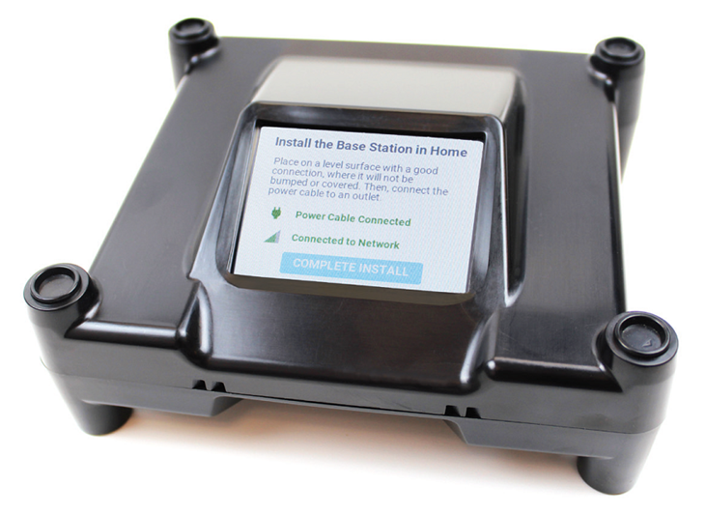

I have read or had read to me the instructions regarding the use and care of the HomeGuard 20/20 monitoring equipment. I fully understand the instructions and acknowledge that I am responsible for safeguarding this equipment.

Name Signature Date

Case manager Signature Date

**The contents of this document may be eligible for public disclosure. Social Security Numbers are considered confidential information and will be redacted in the event of such a request. This form is governed by Executive Order 16-01, RCW 42.56, and RCW 40.14.**

Distribution: **ORIGINAL** - Case manager file **COPY** - WASPC