**ELECTRONIC MONITORING CONTRACT**

The one-piece Wearable Miniature Tracking Device (WMTD) is water resistant, **not waterproof**! It can be worn in the shower, but not held underwater. **YOU MUST NOT SWIM WITH THE UNIT ON**! Ask your case manager for assistance if you have any questions or concerns regarding the care and use of this device.

     

Name DOC number

Initial the following statements confirming the device you have been issued and acknowledging your understanding of the monitoring instructions, requirements, and care of the assigned device.

The following device has been issued to me:

I am to remain at my residence and the designated locations according to the approved electronic monitoring schedule provided to me. I must remain inside my residence during curfew hours.

I am responsible for the device assigned to me and I will not tamper with or remove the device.

I am responsible for paying for any intentional damage or lose of the device. I understand I may also be charged with a new crime under these circumstances.

I am responsible for keeping this device charged at all times and maintaining the Global Positioning System (GPS) signal.

I must contact my case manager immediately if I have any violations or issues with the GPS/device. During the work week (Mon-Fri), I must report to the office in person to notify my case manager. If GPS/device violations or issues occur on the weekend and I do not have a cell phone or means to call my case manager, I must report to the office in person no later than 11:00 a.m. on the next business day.

I have reviewed this form with my case manager. I fully understand the instructions regarding the use of the WMTD and acknowledge that I am responsible for safeguarding the device.

Signature Date

Case manager Signature Date

**The contents of this document may be eligible for public disclosure. Social Security Numbers are considered confidential information and will be redacted in the event of such a request. This form is governed by Executive Order 16-01, RCW 42.56, and RCW 40.14.**

Distribution: **ORIGINAL** - Case manager file **COPY** - Individual under the Department’s jurisdiction, Imaging file

**ELECTRONIC MONITORING DEVICE**

The one-piece Wearable Miniature Tracking Device (WMTD) will be attached to your ankle and is water resistant, **not waterproof**! There are three lights on the top of the device that are the Power, Global Positioning System (GPS), and Zone LED lights. The WMTD will vibrate indicating that you must check the LEDs to determine any problems and then fix them immediately.

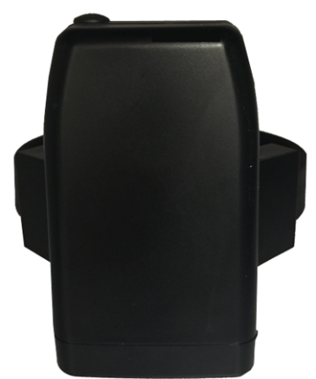**POWER LED LIGHT**

The Power LED will flash **GREEN** when the device is in operation and flash **RED** when it needs charging.

**GPS LED LIGHT**

The GPS LED will be off when the device is not in operation and will flash **GREEN** in unison with the Power and Zone LEDs during activation.

**GPS SIGNAL**

Before entering and after exiting a vehicle or building, you must wait outside a minimum of 3 minutes or until you have gained the signal and all lights are flashing **GREEN.**

The GPS LED will flash **RED** when it is not tracking. You must take corrective action immediately by exiting the building or residence and waiting outside a minimum of 3 minutes or until you have regained the signal.

**ZONE LED LIGHT**

The Zone LED will be off when the device is not in operation and will flash **GREEN** in unison with the Power and GPS LEDs during activation.

**ZONE VIOLATIONS**

The Zone LED will flash **RED** when you have entered an Exclusion Zone (a place you are not supposed to be) or have left before you are scheduled to leave an Inclusion Zone (a place you can or are supposed to be) or have not entered the Inclusion Zone by the scheduled time.

**CHARGING**

The WMTD power cord will be provided for you to charge the device. The end of the cord that connects to the charging port on the WMTD is magnetic and the other end of the power cord is two pronged and plugs into a 110 volt electrical circuit. The WMTD should not be charged by attaching the charging cord to a generator.

The magnetic end of the charger is not dependable to obtain a full charge while you are sleeping, therefore, charging the device before you go to bed is recommended.

The Power LED will turn solid **RED** during charging and solid **GREEN** when the WMTD is fully charged. You must charge the device for a minimum of 2 hours every 12 hours. If your WMTD has no charge, it must charge it for a minimum of 3 hours continuously without interruption, or until fully charged.

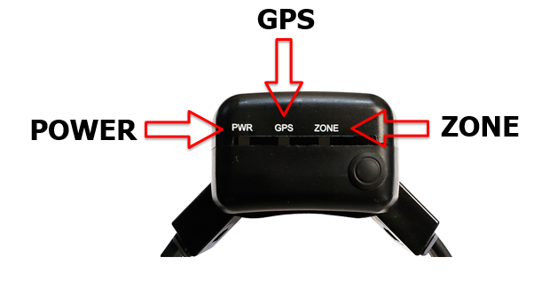**REMINDER**: The WMTD **is** **not waterproof**. It can be worn in the shower, but not held underwater. YOU MUST NOT SWIM WITH THE UNIT ON.